Year 10 Semester One - Paper C

Mathematics Examination
Part Two: Calculators Allowed

Name ________________________________ Teacher _______________________

TIME ALLOWED FOR THIS PAPER
Reading time before commencing : 5 minutes.
Working time for paper : 50 minutes.

MATERIAL REQUIRED /RECOMMENDED FOR THIS PAPER

TO BE PROVIDED BY THE SUPERVISOR
This question paper comprising 7 questions.
Attempt ALL questions.
Total marks for the paper : 75
Answers are to be written on this test booklet in the spaces provided.

TO BE PROVIDED BY THE CANDIDATE
Pens, pencils, eraser, ruler, Scientific Calculator
One (1) A4 pages of notes (handwritten, photocopied or typed on both sides) that may be either personally or commercially produced.

INSTRUCTIONS TO CANDIDATES
Write all answers in the spaces provided - if working is completed on extra pages, indicate on the original question that your working continues elsewhere.
If extra paper is needed in any section, please ask one of the supervisors.

Show all working clearly, in sufficient detail to allow your answers to be checked readily and for marks to be awarded for reasoning. No marks will be awarded to incorrect answers without supporting reasoning.

Question | Possible Marks | Your Mark
1 | 15
2 | 10
3 | 8
4 | 6
5 | 10
6 | 20
7 | 6
Total | 75
Question 1 [15 marks]

a) Liam is working at a surf shop at $12.50 per hour for a 40 hour week.

(i) How much is he paid for 8 hours?

(ii) What is his gross weekly wage?

Liam's deductions are: 21% for income tax and 3% for Health Insurance.
(iii) Calculate the amount he pays in tax each week.

(iv) Calculate the amount he pays in Health Insurance each week?

(v) After deductions, how much of Liam's pay is left to 'take home'?

[7]

b) Jane buys a new car on a hire purchase scheme. The car is advertised for
$18 000. The scheme requires that 20% deposit is paid followed by monthly repayments of $420 for five years.

(i) Calculate the amount of money that is required for the deposit.

(ii) Calculate the amount that is paid in the 5 years.

(iii) How much did the car cost in total?

(iv) What do you notice?

[8]

Question 2 [10 marks]

a) 5kg of juicing carrots cost $3.99.

(i) How much for 1 kg of carrots?

(ii) How much for 10 kg of carrots?

(iii) How much for 3 kg of carrots?

[3]

b) Domonic saves $424 in 16 weeks at a constant rate.

(i) How much did he save by the end of week 9?

(ii) How long did it take him to save $318?

[4]
c) It takes 2 people 12 hours to complete a job. If each person can work at the same rate, how long would it take

(i) 1 person to complete the job?

(ii) 6 people to complete the job?

[3]
Question 3 [8 marks]

a) The speed limit in country areas is 110 km/hour. What is the maximum possible distance that can be travelled in:

(i) 2 hours?

(ii) 30 mins?

[3]

b) Water flows at a rate of 40 L per minute.

(i) How much water is used in a 3 minute shower?

(ii) How long did a shower last if 200L of water was consumed?

[3]

b) The drug ibuprofen is found in Nurofen for children at a concentration of
100 mg/5 mL.
The dosage for a child (7-9 yrs of age) is 10 mL.
How much of the drug is administered in one dose?

[2]

Question 4 [6 marks]

The length of a rectangular lot is 3 metres more than its width.

a) Find the area of various rectangles given this condition by completing the table below.

Width | Length  (Width + 3) | Area
1 m
2 m | 5 m (ie 2 + 3) | 10 m²
3 m
4 m
5 m
6 m

[5]

b) State the length and width of the rectangular region if an area of 40 m² is required?

[1]
Question 5 [10 marks]

Find the next 3 numbers for each number sequence below. For each sequence describe how you get your numbers from the previous number(s).

a) 2, 4, 6, 8, 10, ____, _____, _____

Description:

[2]

b) 2, 4, 8, 16, 32, ____, _____, _____

Description:

[2]

c) 1, 4, 9, 16, 25, ____, _____, _____

Description:

[4]

d) 50, 42, 34, 26, 18, ____, _____, _____

Description:

[2]

Question 6 [18 marks]

a) Calculate the perimeter and area of the following shapes.
(i) (ii)
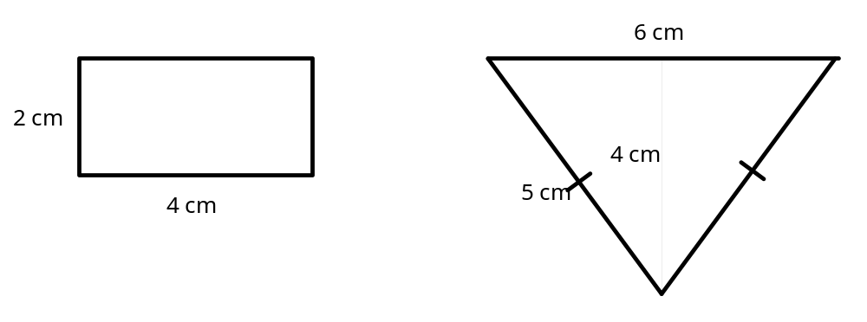

Perimeter: Perimeter:

Area: Area:

[6]

b) (i) Give the dimensions (length and width) of TWO rectangles that have a perimeter of 16 cm.

[2]
(ii) Give the dimensions of TWO rectangles that have an area of 24 cm².

[2]

c) Find the volume of each of the shapes below by counting the number of cubic units in each
(i) (ii)
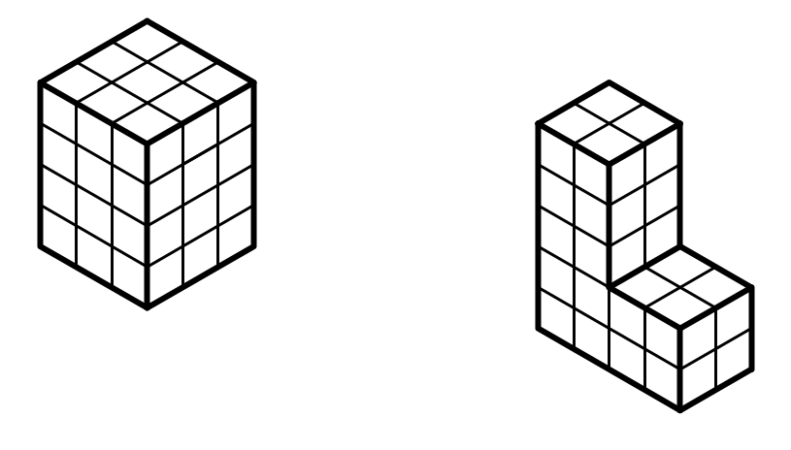
[4]

d) On the isometric grid below, draw TWO different shapes that would have a volume of 8 cm³.



[6]

Question 7 [6 marks]

a) Use the grid to enlarge the drawing.
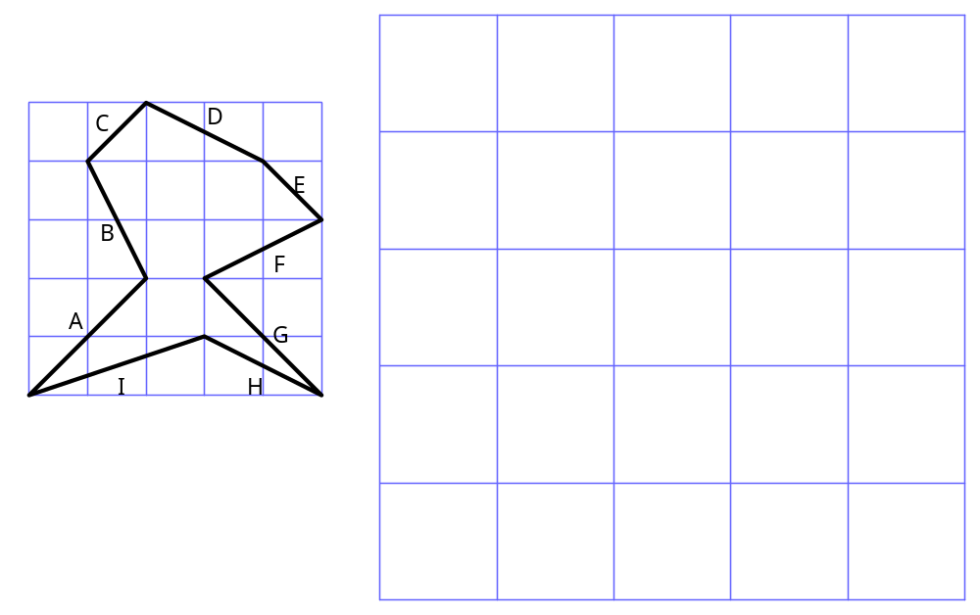
[3]

b) (i) Measure the length of the line labelled C in the first diagram to the nearest millimetre.

(ii) Measure the length of the line that you drew that corresponds to C to the nearest millimetre.

(iii) By what scale factor has the original shape been enlarged?

[3]

